STATE OF NORTH CAROLINA ROBESON COUNTY
COUNTY OF ROBESON BOARD OF ELECTIONS

NOTICE OF PROTEST HEARING

IN RE: THE TOWN OF RED SPRINGS
MAYOR ELECTION
NOTICE is hereby given that the members of the Robeson County Board of Elections will hold a protest hearing on January 9, 2026 at 10:00AM regarding the 2025 Mayoral election for the Town of Red Springs.
The hearing will be held in the Robeson County Board of Elections boardroom located at 800 N. Walnut Street, Lumberton, NC.
The protester, any candidate likely to be affected and any person determined by the Board to have a significant and relevant interest in the resolution of the protest shall have an opportunity to introduce evidence. All witnesses shall be placed under oath before testifying.
Upon request by a protester, any candidate, or interested party, the Chair or any two members of the County Board may issue subpoenas at their discretion, for persons or documents. Any party who is represented by counsel shall be responsible for issuing any subpoenas they deem necessary.

The Board reserves the right to continue the hearing pursuant to 08 NCAC 02.0110(c) if it determines securing additional evidence is necessary to conclude the hearing.
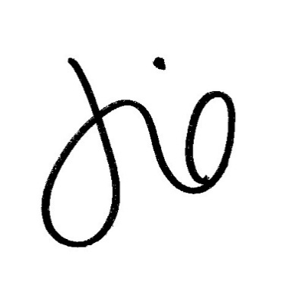

Jessica T Davis
Director, Robeson County Board of Elections

