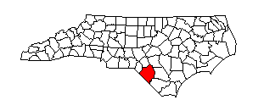
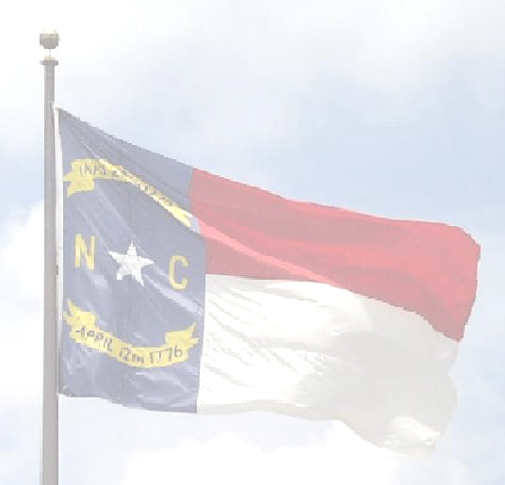
Robeson County Board of Elections
Post Office Box 2159
Lumberton, North Carolina 28359

Office
Robeson County Board of Elections 800 N. Walnut Street
Larry Townsend, Chairman Phone
Gretchen Lutz, Secretary (910) 671-3080
Marion Thompson, Member Fax
Krystle Melvin, Member 910-737-5094
Patricia Dow, Member Director
Tina M. Bledsoe

ROBESON COUNTY BOARD OF ELECTIONS
September 12th, 2023
Notice of Cancelled Meeting

The Robeson County Board of Elections has cancelled their Regularly Scheduled Board Meeting, that is scheduled to be held on Tuesday, September 19th, 2023 at 6:00 p.m.

The next regularly scheduled Absentee Board Meeting is scheduled to be held on Tuesday, October 3rd, 2023.at 6:00 p.m., at the office of the Board of Elections. Located at 800 North Walnut Street, Lumberton, NC. 28358. Please Note: It is possible this meeting will be cancelled; absentee ballots are not mailed out for a municipal election until October 6th per GS 163-227.10.
If cancelled the next scheduled absentee meeting will be held on October 10th, 2023 at 6:00 p.m.

Any questions or remarks, please contact the office at 910-671-3080, during business hours. Monday-Friday 8:15-5:15 p.m.

Tina M. Bledsoe, Director
800 North walnut Street
Lumberton, NC. 28358
(O) 910-671-3080
(F) 910-737-5094
Tina.bledsoe@co.robeson.nc.us

